Who we are  National Lawyers Guild - Rochester Chapter  Email: Rochester@NLG.org  Other Contact: (EWOC) workerorganizing@gmail.com  NLG Rochester on the Web: XXXXX |  |  | YOUR RIGHT  TO ORGANIZE AT WORK  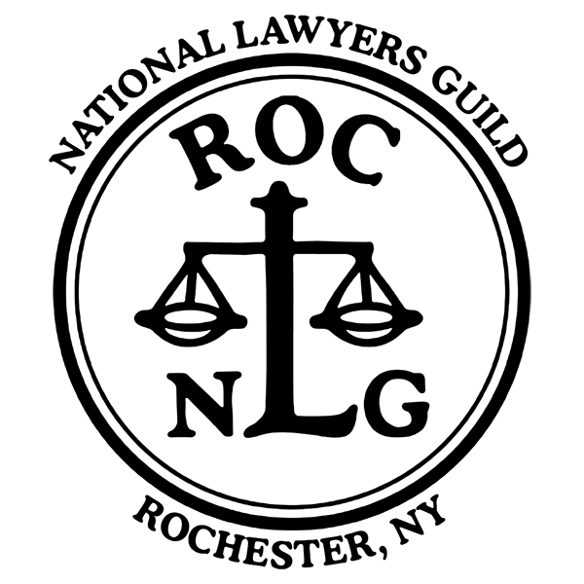  - Rochester@NLG.org

Table of Contents  Worker Rights 1  What Employers Can’t Do 2  Frequently Asked Questions 3  Four Steps to Form a Union 4  Further Information 5 |  |  | Further information:  Check out Emergency Workplace Organizing Committee (EWOC),  Email: workerorganizing@gmail.com  And see  General Organizing and Organizing Conversations  EWOC resources
 |  |  | 5

Four Steps  to Form a Union  When you and your co-workers come together to form a union, you get the right to negotiate with your employer over wages, benefits and working conditions. No matter what the industry you are in, or the labor law that covers it, the process for forming a union is similar.  - Get together with your co-workers who may share a common interest in organizing a union.  - Talk to a union organizer in order to strategize and to learn the next steps.  - Talk to your co-workers to build support for the union.  - Show that support through an election or a card-check once you have a strong majority.  Once your union is official, you’ll choose your leaders and negotiate a contract. The process is democratic, and the more inclusive you can be, the stronger your union will be. |  |  | Worker Rights  The National Labor Relations Act protects most private sector workers’ right to act with coworkers to improve wages and working conditions. The National Labor Relations Act protects the right to organize a union and collectively bargain with employers.  Workers covered by the National Labor Relations Act have the right to:  - Talk about a union during breaks, or before or after work, but usually not during work time.  - Distribute union literature to coworkers. You can do this on your own time in non-working areas (for example the cafeteria or parking lot).  - Attend union meetings.  - Encourage coworkers to form a union.  - Wear union buttons, t-shirts, stickers, hats and other union items on the job as long as your dress code does not prohibit those kinds of things generally. If you are allowed to wear a Sierra Club or Rotary Club button at work, you should be allowed to wear a union button.
4 |  |  | 1

What Employers  Can’t Legally Do  It is against the law for your employer to:  - Threaten to fire you for supporting the union.  - Spy on you about your union activity.  - Discriminate against you (treat you worse) when it comes to hiring, promotion, layoffs, benefits or other working conditions because you support the union.  - Make threats or promises related to union activity. An example of an illegal threat is saying that the workplace will close if workers form a union. An example of a promise is that if workers’ reject the union, the employer will raise wages. |  |  | FAQs  Who Is Not Covered by The National Labor Relations Act (NLRA)?  The NLRA does not apply to public sector workers (federal, state, county, and municipal employees), true independent contractors, supervisors or managers who can hire or fire people, and confidential employees.  The NLRA also excludes farm workers, and domestic workers; NY state law grants farm workers the right to organize and collectively bargain. However, farm workers do not have the right to strike in NY.  What about New York State public sector workers?  Most New York State and local public sector workers have the right to form, join and participate in, or to refrain from forming, joining, or participating in, any employee organization of their own choosing.  Most NY public employees have the right to be represented by employee organizations, to negotiate collectively with their public employers in the determination of their terms and conditions of employment, and the administration of grievances arising thereunder.
2 |  |  | 3

